1. 
2. A diagram of a company

   Description automatically generated with medium confidence
3. Let’s make some changes in this branch.
4. 
6. A screen shot of a computer program

   Description automatically generated
7. 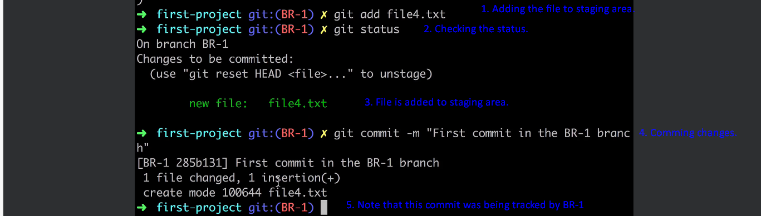
8. 